**Question 41 (WATP Sem II 2017) (20 marks)**

1. A minute sample of DNA has been obtained from an individual for paternity testing and to establish any possible link with a rare genetic disorder.

i. Outline two **named** techniques in biotechnology that are carried out before proceeding to

DNA sequencing of the genome. (11 marks)

ii. Rapid developments in genomic testing methods have made the sequencing of a

person’s DNA faster and cost-efficient. List some ethical issues involved in the use of the

genomic information as a `lifetime health resource’. (3 marks)

1. Define gene therapy and cell replacement therapy. For each of these techniques, state an example of its application and discuss any ethical issues raised by this kind of human intervention. (6 marks)

**From WATP Sem II 2016 exam:**

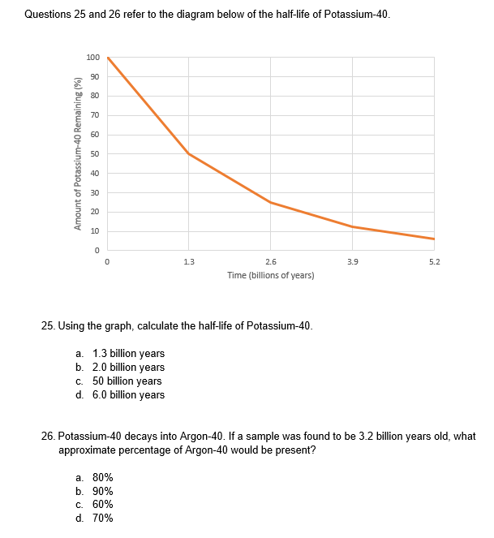

**From WATP 2015 Sem II Paper**

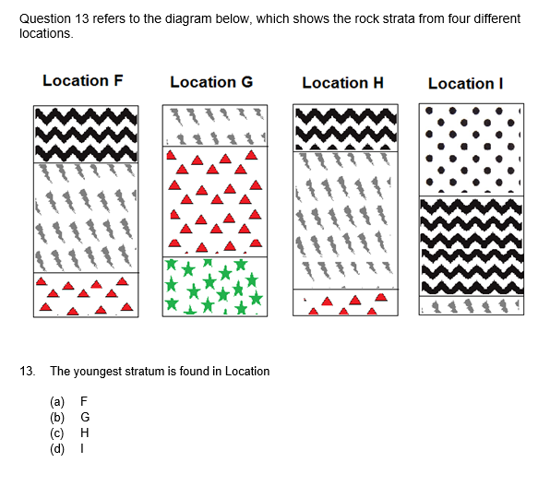

**From WATP 2015 Sem II Paper**

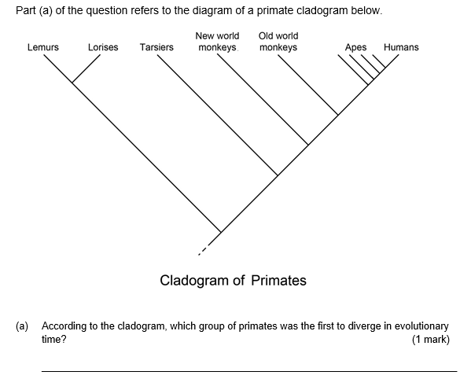

**From WATP 2015 Sem II Exam**

1. Scientists trying to establish the evolutionary relationship between primates decided to complete a comparative study using nuclear DNA.
2. Describe how this would be conducted. (2 marks)

________________________________________________________________________________________________________________________________________________________________________________________________________________________________________________________________________________

1. Explain how it could show evolutionary relationships between primates. (1 mark)

______________________________________________________________ ______________________________________________________________ ______________________________________________________________

1. Palaeontologists are yet to find a common ancestor for chimpanzees and humans in the fossil record. It is thought to have lived between 5 and 7 million years ago.
2. Suggest **three** reasons why such a fossil has been hard to find. (3 marks)

____________________________________________________________________________________________________________________________________________________________________________________________________________________________________________________________________________________________________________________________________________________

1. A scientist who is completing excavations in Eastern Africa unearths a fossil he believes is the ‘missing link’ between chimpanzees and humans. If this is true, explain why C-14 dating would be of little use in this scenario. (2 marks)

____________________________________________________________________________________________________________________________________________________________________________________________________________

**Question 41 From WATP 2015 Sem II Exam**

The HEXA gene codes for an enzyme that breaks down lipids found within cells, mostly in the central nervous system. If both alleles for this gene are mutated, the individual will suffer from a fatal disease called Tay-Sachs.

1. In Australia, the frequency of the mutated allele is very low, about 1 in 300. In the Ashkenazi Jewish population, however, the frequency is about 1 in 26.

Explain **two** evolutionary mechanisms that scientists reason could be the cause for such different gene pools.

(7 marks)

1. Researchers are hoping to start human clinical trials for Tay-Sachs disease using gene therapy. They hope to achieve this by using modified viruses that are infused into cerebrospinal fluid.

Describe the process of how the viruses would be genetically engineered and then how it could lead to a treatment for Tay-Sachs.

(13 marks)